RTAB-MAP

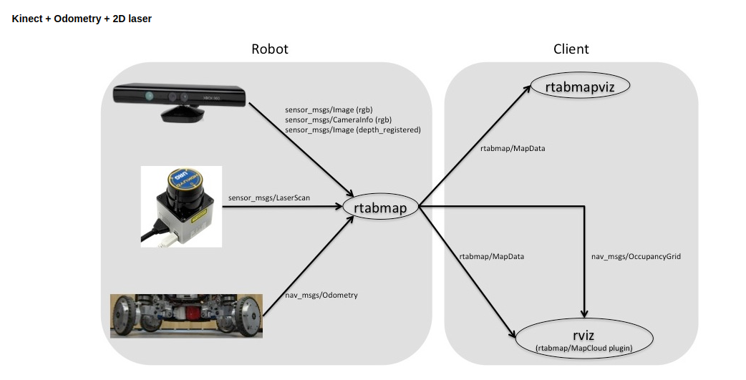

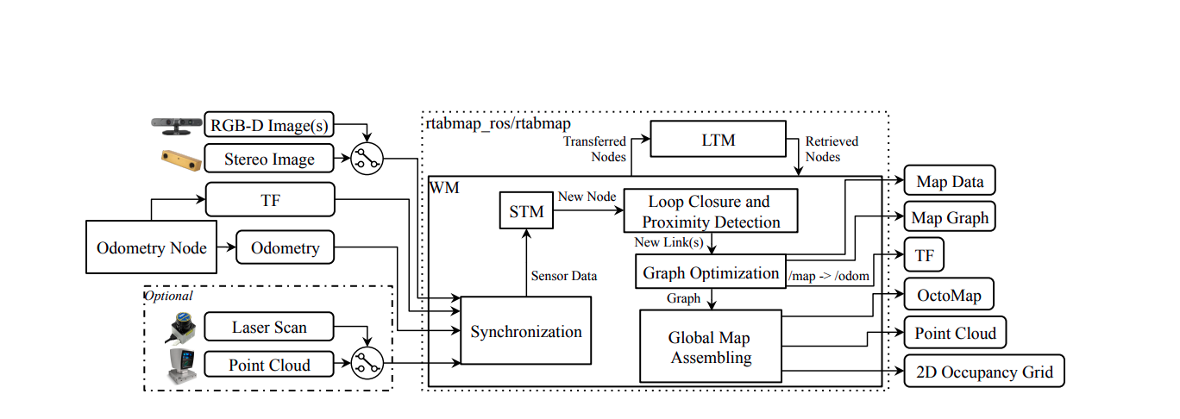
Block diagram of rtabmap ROS node

RTAB-Map is a graph-based SLAM approach that has been integrated in ROS as the rtabmap ros package since 2013. Figure 1 shows its main ROS node called rtabmap. The odometry is an external input to RTABMap, which means that SLAM can also be done using any kind of odometry to use what is appropriate for a given application and robot. The structure of the map is a graph with nodes and links. After sensor synchronization, the Short-Term Memory (STM) module creates a node memorizing the odometry pose, sensor’s raw data and additional information useful for next modules (e.g., visual words for Loop Closure and Proximity Detection, and local occupancy grid for Global Map Assembling). Nodes are created at a fixed rate “Rtabmap/DetectionRate” set in milliseconds according to how much data created from nodes should overlap each other. For example, if the robot is moving fast and sensor range is small, the detection rate should be increased to make sure that data of successive nodes overlap, but setting it too high would unnecessary increase memory usage and computation time. A link contains a rigid transformation between two nodes. There are three kind of links: Neighbor, Loop Closure and Proximity links. Neighbor links are added in the STM between consecutive nodes with odometry transformation. Loop Closure and Proximity links are added through loop closure detection or proximity detection, respectively. All the links are used as constraints for graph optimization. When there is a new loop closure or proximity link added to the graph, graph optimization propagates the computed error to the whole graph, to decrease odometry drift. With the graph optimized, OctoMap, Point Cloud and 2D Occupancy Grid outputs can be assembled and published to external modules. Odometry correction to derive the robot localization in map frame is also available through tf [Foote, 2013] /map→/odom.

RTAB-Map’ memory management approach [Labb´e and Michaud, 2013] runs on top of graph management modules. It is used to limit the size of the graph so that long-term online SLAM can be achieved in large environments. Without memory management, as the graph grows, processing time for modules like Loop Closure and Proximity Detection, Graph Optimization and Global Map Assembling can eventually exceed real-time constraints, i.e., processing time can become greater than the node acquisition cycle time. Basically, RTAB-Map’s memory is divided into a Working Memory (WM) and a Long-Term Memory (LTM). When a node is transferred to LTM, it is not available anymore for modules inside the WM. When RTAB-Map’s update time exceeds the fixed time threshold “Rtabmap/TimeThr”, some nodes in WM are transferred to LTM to limit the size of the WM and decrease the update time. Similarly to the fixed time threshold, there is also a memory threshold “Rtabmap/MemoryThr” that can be used to set the maximum number of nodes that WM can hold. To determine which nodes to transfer to LTM, a weighting mechanism identifies locations that are more important than others, using heuristics such as the longer a location has been observed, the more important it is and therefore should be left in the WM. To do so, when creating a new node, STM initializes the node’s weight to 0 and compares it visually (deriving a percentage of corresponding visual words) with the last node in the graph. If they are similar (with the percentage of corresponding visual words over the similarity threshold “Mem/RehearsalSimilarity”), the weight of the new node is increased by one plus the weight of the last node. The weight of the last node is reset to 0, and the last node is discarded if the robot is not moving to avoid increasing uselessly the graph size. When the time or the memory thresholds are reached, the oldest of the smallest weighted nodes are transferred to LTM first. When a loop closure happens with a location in the WM, neighbor nodes of this location can be brought back from LTM to WM for more loop closure and proximity detections. As the robot is moving in a previously visited area, it can then remember the past locations incrementally to extend the current assembled map and localize using past locations [Labb´e and Michaud, 2017].

RTAB-Map (Real-Time Appearance-Based Mapping) is a RGB-D SLAM approach based on a loop closure detector. The loop closure detector uses a bag-of-words approach in order to determinate if a new image detected by an RGB-D sensor it is from a new location or from a location that it has been already visited.

